Salesforce Configuration Model-2_1 Assignment
Add three new status values on task(Case) as follows :
create assignment status picklist field on task(Case) object and add the following values
1. In-Review
2. Re-Opened
- Completed
1. Approval Process on Project Task:
1. Once the task status is changed to 'In-Review' task should be submitted for approval to 'Project Manager'.
2. If the manager approves the approval request, task status should be set to 'Completed'
3. If the manager rejects the approval request, task status should be set to 'Re-Opened'

<Enable approval via email and Chatter>
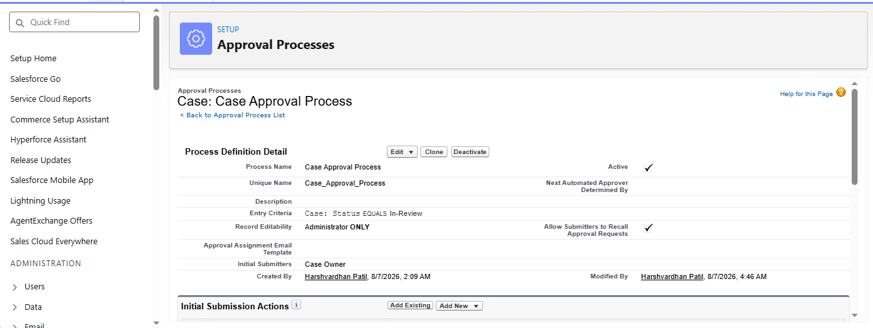
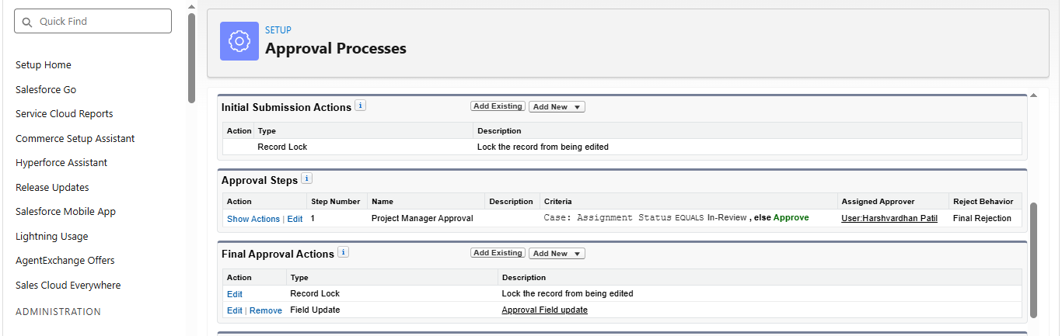
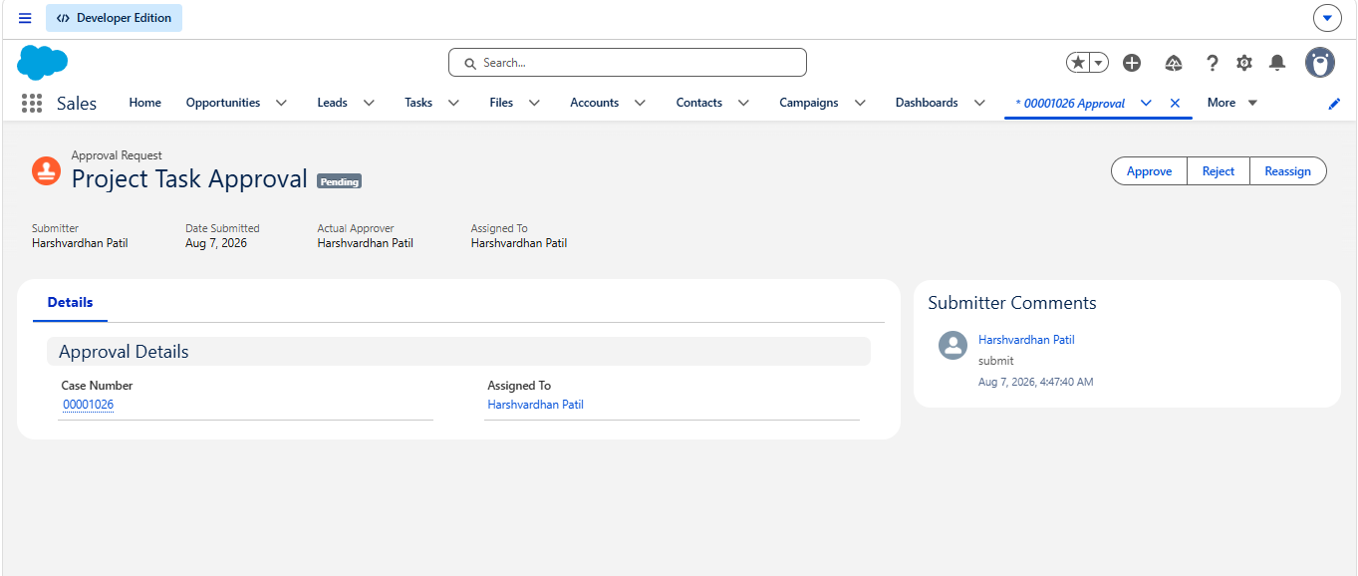
2. Escalation Rule :
1. If the due date of the task is passed escalate the case and send notification to project manager.(Use ‘Escalated Case Notification’ template to notify the User)
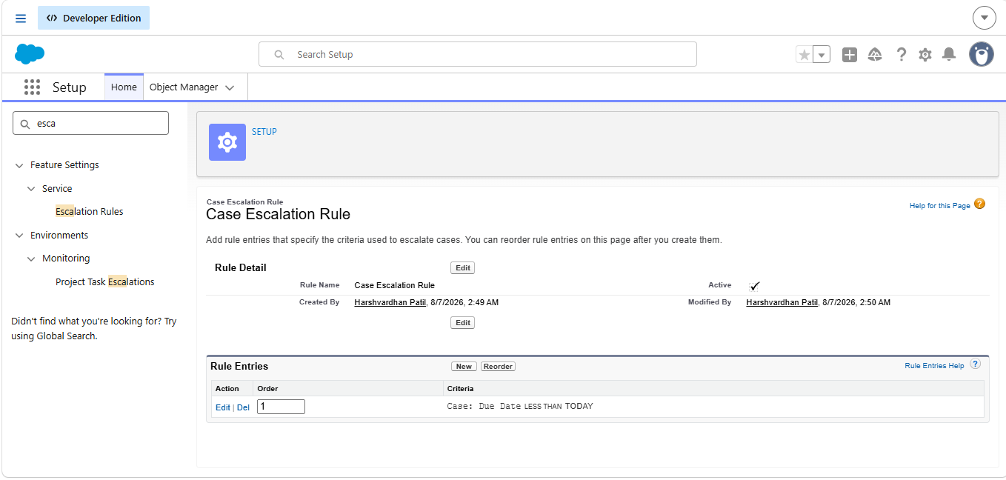
3. Auto-Response Rule

Create Auto-Response rule if case is created through email (Use Support: Case Created (Web Inquiries) email template.)

Hint : First you need to set up Email-to-Case settings to create case through email.
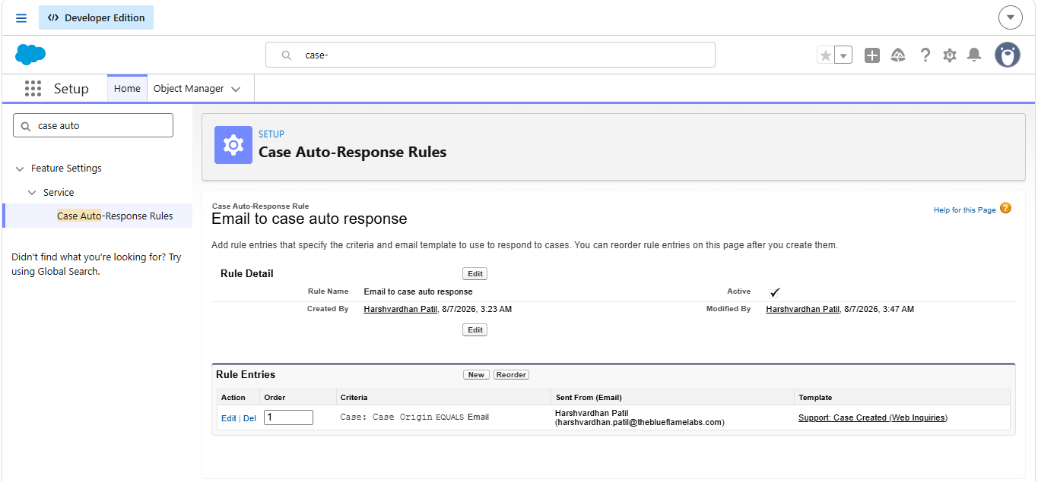
Trailhead
1. Salesforce Flow
2. Build a Discount Approval process (project)
3. Create a process for managing support cases(project)
4. Automate Case Management (module name service cloud for lightning experience)

